USING GRIDWORLD in NewBeans:

- Work with “firstProject”

The first Case Study project to RUN is called “firstProject”. The code is provided and actually interfaces with the gridworld.jar (contains the graphics and other related classes). MAKE sure you can work with the case study by creating projects in NETBEANS that execute all three of the Case Study Projects). firstProject is the one we will build first.

In NETBEANS:

- Create a new Project with Existing Sources
- Browse to the GRIDWORLD folder and Locate the firstProject folder (that already exists). You are creating a project with the SAME name as the external source (firstProject)
- Name your Project “firstProject”
- Open
- Then add in the gridworld.jar by RIGHT clicking Libraries folder to add JAR/file and browsing to the GRIDWORLD folder and Selecting the gridworld.jar, OPEN
- When your project opens, it should contain BugRunner.java in Source Packages and gridworld.jar in the Libraries folder
- Now, RUN the project

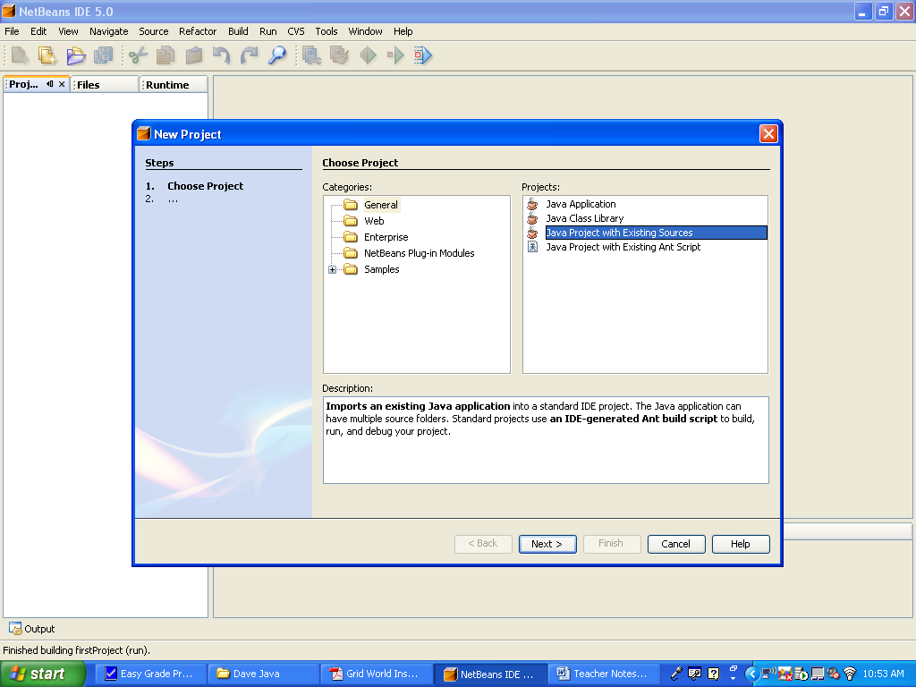
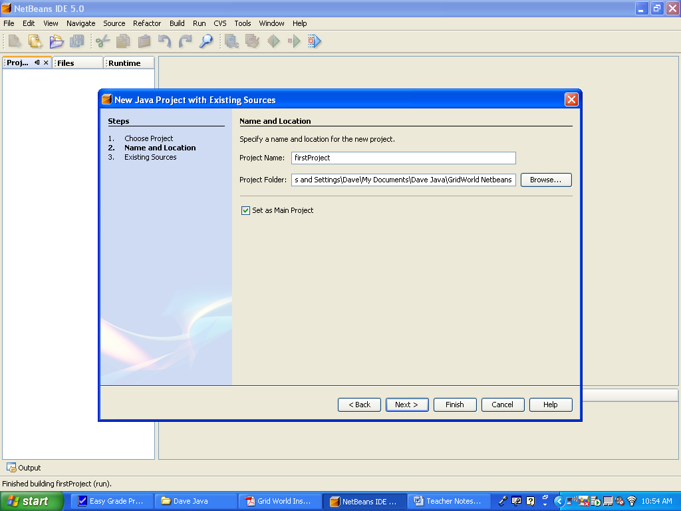
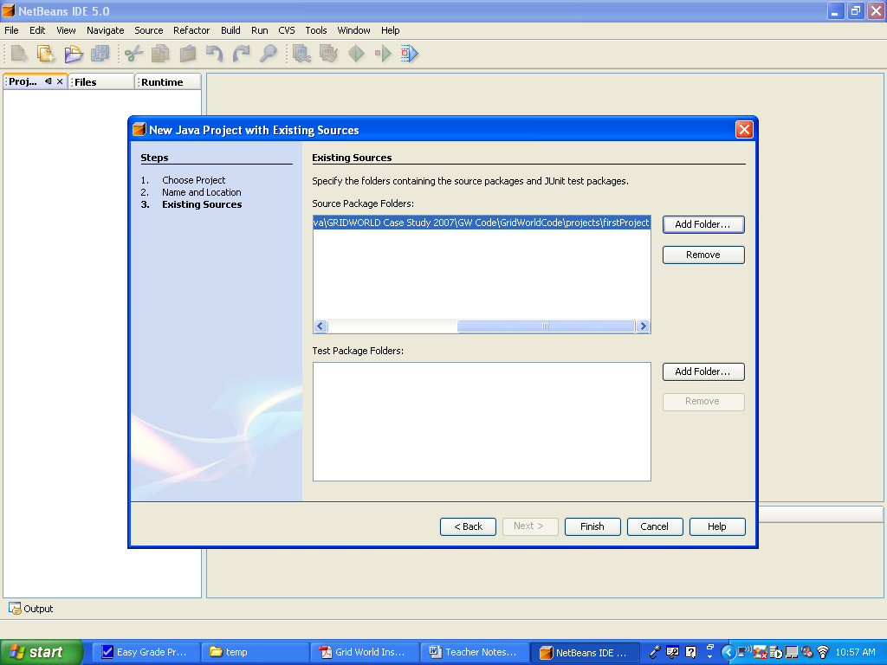

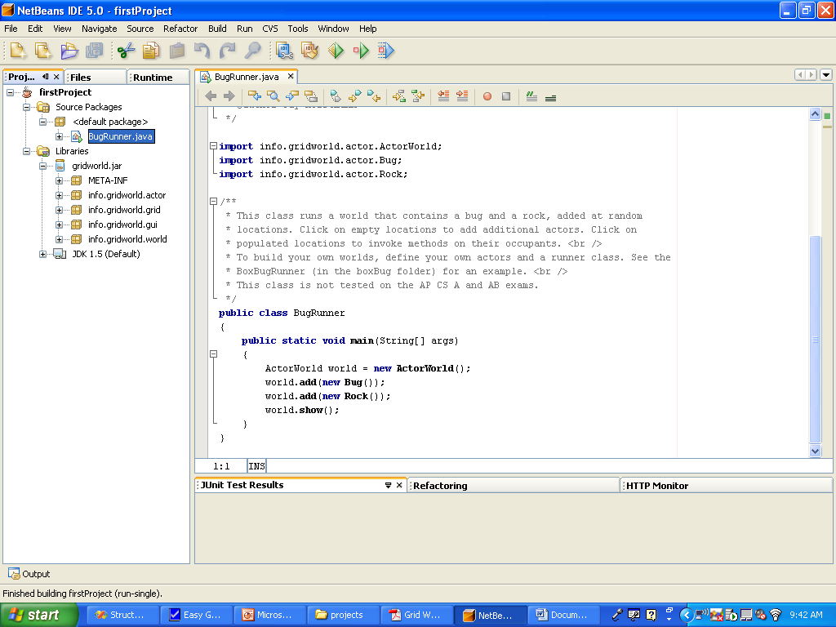

- Run the BugRunner and the display will look like the following:

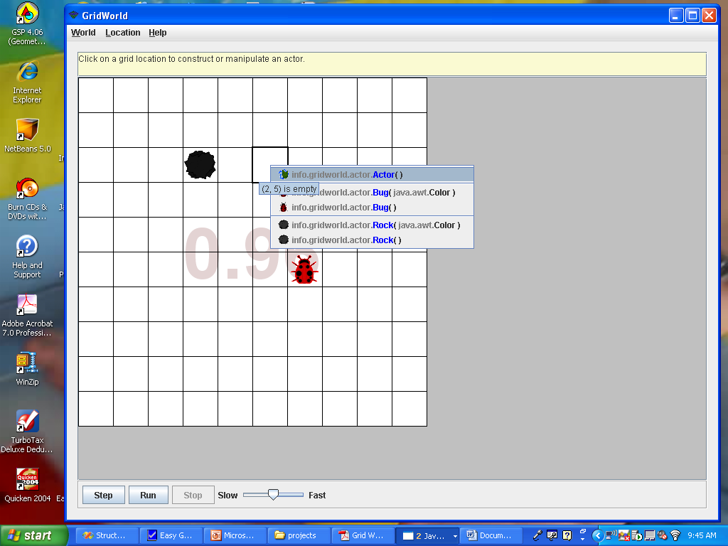

Follow the same process for the other the projects: BoxBug and Critters

